Chapter 1

Introduction

This study is intended to create a benchmark for performance testing of spatial databases, which support the storage and operations of spatial data types. This idea was inspired by the industry standard database benchmark TPC-H [TPC-H 2011, TPC], which has been widely used in testing traditional relational databases.

Due to the growth of demand for technologies in geographic information, the implementation standard for spatial information published by the Open Geospatial Consortium (OGC) has been supported by major database management systems (DBMS), such as Microsoft® SQL Server and Oracle®. Although a few spatial benchmarks have been proposed [Ray 2011], there are no standard or widely-used spatial database benchmarks available.

Our prototype spatial database benchmark, Space Bench, is the main product of this study. This thesis presents the main components of the benchmark, including the spatial database schema, the spatial queries, and the algorithms used to generate data to populate the benchmark database. Finally, we also present some initial results from the application of the benchmark to Microsoft® SQL Server 2008 R2.

The rest of this thesis is organized as follows. Chapter 2 introduces traditional relational databases and OGC spatial extensions. Chapter 3 summaries the most well-known database benchmarks (spatial and non-spatial) and explains the motivation for Space Bench. Chapter 4 presents the primary components of Space Bench. Chapter 5 provides the initial testing of Space Bench. Finally, Chapter 6 summarizes our results and discusses future work.

Chapter 2

Relational and Spatial Databases

The chapter presents information required to understand relational databases and their spatial extensions. Additionally, in an effort to motivate the need for spatial extensions, it also introduces a way for storing spatial information in a traditional, non-spatially extended relational database.

2.1 Relational Databases

This section presents a brief summary of databases and relational databases, in particular. For a more complete summary the reader is referred to any of the widely available books such as the one by Silberschatz [Silberschatz 2010] or Elmasri [Elmasri 2010] on database systems.

2.1.1 The Relational Model
The term database is typically used to refer to an organized collection of data in digital form. The term database management system (DBMS) is used to refer to a software package that controls the creation, population, organization, maintenance and use of databases. Additionally, a DBMS manages multiple users’ concurrent access, insertion, update and retrieval of data to and from a database.

A relational database organizes data in 2-dimension tables, each of which consists of a number of columns (fields) corresponding to a set of attributes. In another words, a relational table consists of a number of rows (records) for different entities, each of which has a value for each of the columns. For example, a table storing information on individuals might have columns for the attributes such as ID, name, city, etc, as shown in Figure 1.

ID | Name | City | Country
1 | Espen | Oslo | Norway
2 | Harald | Munich | Germany
3 | Sam | San Jose | USA

Figure 1. Example of relational table.

Frequently a table will have a primary key, which is a subset of columns that uniquely identifies each row in the table. Similarly, a foreign key is a subset of columns of one table that makes reference to the primary key of another table. For example, Figure 2 shows three tables containing information on a banking enterprise called customer, depositor, and account. Note that the customer-id and account-number columns are foreign key references to the primary keys of the customer and account tables, respectively.

customer-id | customer-name | customer-street | customer-city
192-83 | Johnson | 12 Alma St. | Palo Alto
019-28 | Smith | 4 North St. | Rye
182-73 | Turner | 123 Putnam Ave | Stamford
321-12 | Jones | 100 Main St. | Harrison
677-89 | Hayes | 3 Main St. | Harrison
(a) the customer table

customer-id | account-number |  | account-number | balance
192-83 | A-101 |  | A-101 | 500
192-83 | A-201 |  | A-215 | 700
019-28 | A-215 |  | A-102 | 400
182-73 | A-305 |  | A-217 | 750
321-12 | A-217 |  | A-305 | 350
677-89 | A-102 |  | A-201 | 900
(b) the depositor table (c) the account table

Figure 2. Tables from a banking enterprise (from [Silberschatz 2010]).

2.1.2 Structured Query Language (SQL)
A database is typically accessed and managed through a programming language supported by the DBMS. Unquestionably the most widely-used relational database language is Structured Query Language (SQL). For over two decades, SQL has been a standard of American National Standards Institute (ANSI), and of the International Organization for Standardization (ISO). SQL was developed by IBM in the 1970s, and the interested reader is referred to Silberschatz [Silberschatz 2010] or Elmasri [Elmasri 2010] for historical details on its creation and evolution.

From a technical perspective, the scope of SQL includes all aspects of database manipulation (access) and management, including database and table creation and modification, in addition to data insertion, deletion, modification and retrieval. SQL also provides commands for controlling user access, storage management, backup and recovery, and many other functions necessary for effective database use and administration.

The definition of the tables in a database is frequently referred to as the schema of the database. The schema is defined through a part of SQL called Data Definition Language (DDL). DDL provides commands for the creation, modification and deletion of tables. The definition of a table includes the table name, plus the names and data types of the columns of the table. DDL also includes commands for views, which are virtual tables whose columns and data come from one or more actual tables in the database.

The database access part of SQL is called Data Manipulation Language (DML). The basic structure of SQL query for data retrieval consists of three clauses: select, from and where. Figure 3 shows a typical SQL query based on the tables shown in Figure 2. This query will find the names of all customers, their account numbers and balances, for those customers who have an account at the bank. The query “joins” the three tables of the database by comparing the customer-id and account-number fields of the tables. For more details on SQL, the interested reader is referred to Silberschatz [Silberschatz 2010] or Elmasri [Elmasri 2010].

SELECT customer.customer-name, account.account-number, account.balance
FROM customer, account, depositor
WHERE customer.customer-id. = depositor.customer-id AND
account.account-number = depositor.account-number

Figure 3: Example of typical SQL query.

2.2 Relational Databases and Spatial Data
Dating back to the 1970s, most of the data stored in traditional relational databases was based on a small collection of types including integers, real numbers, and strings. In contrast to many of the more “complex” types that are now available in relational databases, data based on the simpler numeric or string types is sometimes referred to as field-able, or sometimes, structured data. For example, the tables shown in Figure 2 contain entirely field-able or structure data.

These basic types have been sufficient for many databases applications. However, there are a number of different types of data for which the relational model has proven to be insufficient, or difficult to use at best. Among others, this includes such things as text, image, and audio data. In contrast to the simpler types mentioned above, types such as these are commonly referred to as either unstructured or semi-structured forms of data.

One type of unstructured data that is important to this thesis is spatial data. In short, spatial data is any type of data that has a spatial reference in n-dimensional space. In most spatial applications, n is either 2 or 3. Here we are most interested in the case where n = 2, although the work could be extended to higher dimensions in a conceptually straight-forward way.

More specifically, spatial data consists of information about spatial objects. Web mapping services, such as Google Map, manipulate spatial objects such as locations, streets, rivers, lakes, cities, countries, etc. On a traditional map, these spatial objects frequently appear as points, curves and surfaces. In digital form these objects are represented by points, line strings and polygons, which we will define more precisely later. For example, a location is represented by a point, a river by a line-string (a string of line segments with linear interpolation), and a building by a polygon. Although there are many other types of geometric objects, points, line-strings, and polygons are sufficient for representing most spatial data.

As an example, Figure 4 shows a point, a line-string and a polygon in abstract form, whereas Figure 5 shows how the 38 districts and counties of Chongqing, China can be roughly approximated by a collection of polygons by using Microsoft SQL Server.

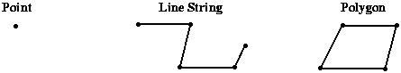

Figure 4. Point, line-string and polygon in abstract form.

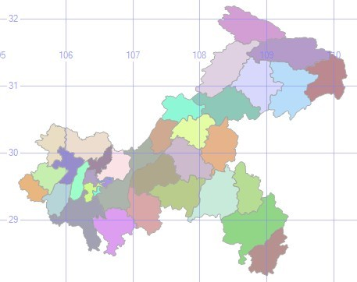

Figure 5. A map of Chongqing, China.

As noted previously, traditional relational databases make use of very basic types including integers, real numbers and strings. These types are widely used and supported by all relational database vendors, in particular, those conforming to the SQL ANSI and ISO standards which require support for such types. Although spatial data such as that described above can be represented and stored in a relational database, such an approach suffers from several drawbacks.

More specifically, a straightforward method for storing spatial data in a traditional relational database is to decompose all spatial objects into their respective points, and store those points in tables in a way that makes it possible to reconstruct the represented spatial objects [Shekhar 2003].

For example, suppose data associated with census blocks is to be stored in a relational database and, in particular, that information associated with the (square) census block shown in Figure 6 is to be stored. In this case the data can be stored in four tables, as shown in Figure 7, with the census-blocks table containing the basic information about the census block, including its name (340), area (1), and population (1839), in addition to the id-number of the spatial object, or rather polygon in this case, that makes up its boundary (1050). The polygon table then contains an entry for each edge, or rather line-segment, that makes up the polygon (in this case there are 4 edges), and each edge then has two entries in the edge table, one for each end-point. Finally, the x and y coordinates for each point are stored in the point table.

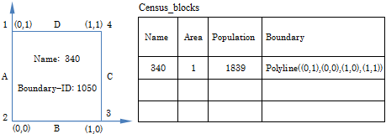

Figure 6. A census block

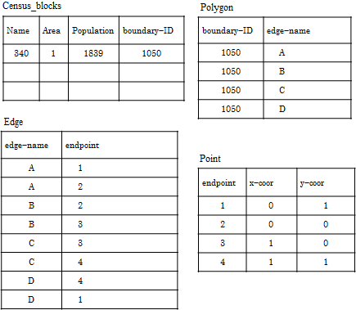

Figure 7. Storing a census block (i.e., polygon) in a relational database.

Note that the approach used in Figure 7 for storing 2-dimensional spatial data is sufficient for representing any spatial data in the form of points, line-strings, or polygons. Furthermore, almost any geometric calculation involving these spatial objects would be possible simply by extracting the spatial data, reconstructing the spatial objects and invoking whatever algorithms on that data were necessary. For example, computing the area of a given polygon, determining which polygons overlap, computing the length of a line-string, or determining which pairs of line-strings cross, are computationally tractable using this data.

There are, however, several problems with this approach. Firstly, constantly extracting and reconstructing spatial objects from such a collection of tables is very cumbersome and computationally inefficient. Secondly, once the required spatial objects have been extracted and reconstructed, algorithms external to the DBMS would have to be invoked to perform whatever geometric calculations are required. Such algorithms would have to be supplied by either a third-party vendor, or coded from scratch by the application developer. Although this approach is technically feasible, it is not convenient or efficient.

2.3 Spatial Extensions

In this section we describe extensions that enhance relational DBMS support for storing and manipulating spatial data. At the programmatic level, these extensions include the addition of spatial types and spatial operations. The spatial types provide an extension to DDL that simplifies the storage of spatial data, and the spatial operations provide an extension to DML that makes queries possible that manipulate spatial data.

2.3.1 OGC Simple Feature Geometry Model
In response to the need for better support for spatial data in relational database systems, the Open Geospatial Consortium (OGC) has developed and published a spatial information standard called the OpenGIS® Implementation Standard for spatial information. This standard is founded upon what is commonly referred to as the simple feature geometry, which models spatial objects by a variety of geometry types. The standard covers the model, operations, representation formats and spatial reference systems (coordinate systems) for simple feature geometry [Herring 2010].

Although the standard is technically non-binding, most relational database vendors have provided support for types and operations that are either similar or identical to those defined by the standard. This includes, among others, Microsoft® SQL Server, Oracle®, IBM® DB2, and even open-source systems such as MySQL® and Postgres®.

A fundamental part of the OpenGIS® Implementation Standard, shown in Figure 8, is the Object Model for Simple Feature Geometry [Herring 2010]. The purpose of this model is to define all of the spatial object types that are covered by this and other OGC spatial standards. In this architecture the root class, Geometry, possesses four subclasses (children) Point, Curve, Surface and GeometryCollection, where GeometryCollection has three subclasses MultiPoint, MultiCurve and MultiSurface. Within this architecture, every class inherits attributes and operations from its superclass.

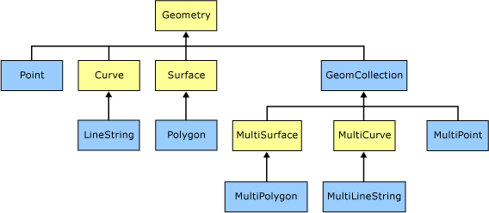

Figure 8. Geometry class hierarchy (instantiable classes specified in blue).

Of the classes shown in Figure 8, only seven are actually defined by the standard as being instantiable, in the sense that geometry objects of those classes can actually be constructed in a database [MSDN, Herring 2010]. Specific DBMSs, however, typically don’t conform exactly to the hierarchy in this regard. For example, SQL Server only supports a single geometry type, i.e., geometry, which is used for all types of geometry objects. Others, such as MySQL, Oracle, and Postgres, for example, support more specific classes, including Point, LineString, and Polygon.

2.3.2 OGC Spatial Data Types
In this section we describe three of the instantiable classes from the OGC Simple Feature Geometry Model in more detail. In particular, we focus on the types that are of interest to this thesis - Point, LineString, and Polygon. Additionally, we also describe a commonly used representation for such objects called the Well Known Text (WKT) format, which is a simple, intuitive and readable format for representing geometric objects and sets of geometric objects, based on spatial coordinates from 2-dimensional space. For details the other four instantiable classes and their WKT representation, the interested reader is referred to the definition of Object Model for Simple Feature Geometry [Herring 2010].

1. Point
A Point represents a single location in 2-d coordinate space. In a plane, a point has a x-coordinate and a y-coordinate. The WKT representation of point (x, y) is simply ‘Point (x y)’. For example, the WKT representation of a point whose x-coordinate is 3, and y-coordinate is 4, is simply the text string ‘POINT (3 4)’. Note we will use upper-case for WKT geometric specifications throughout this thesis for the sake of readabilities. However, that is not required by the standard.

2. LineString
A LineString is a string of straight line segments. Mathematically, a LineString is used to represent a curve, but with linear interpolation between a series of points. Because each pair of consecutive points of a LineString defines a line segment, the WKT representation of a LingString utilizes the coordinates of the points that make up the line segments. For example, the WKT representation of the LineString in Figure 9 is ‘LINESTRING (36 36, 32 12, 70 38)’.

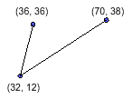

Figure 9. Example of LineString.

A LineString may be closed, in which case it is a ring. If an unclosed LineString does not touch or intersect itself, it is said to be simple; otherwise it is said to be non-simple. If a closed LineString is simple, it is said to be a LinearRing [Herring 2010]. Figure 10 provides examples for the four types of LineString.

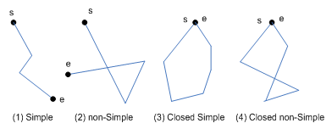

Figure 10. Four types of LineString

3. Polygon
A Polygon is a planar surface formed by a connected Point set, and that is defined by 1 exterior boundary, which is a LinearRing, and 0 or more interior boundaries, also LinearRings. An interior boundary makes up a hole inside a Polygon. Any pair of boundaries in a Polygon must not cross, but they may intersect at a Point as a tangent. Any line segment of a boundary in a Polygon is an edge of the polygon. For example, Figure 11 shows a no-hole polygon, and a polygon containing a single hole.

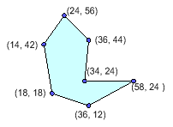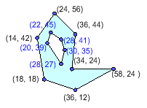

Figure 11. Examples of Polygon

The WKT representation of a polygon describes its exterior and interior boundaries. For example, the WKT representation of the no-hole polygon in Figure 11 is Polygon ((24 56, 14 42, 18 18, 36 12, 58 24, 34 24, 36 44, 24 56)), and the polygon with a hole is Polygon ((24 56, 14 42, 18 18, 36 12, 58 24, 34 24, 36 44, 24 56), (22 45, 20 39, 28 27, 30 35, 28 41, 22 45)).

2.3.3 Spatial Operations
The OpenGIS® Implementation Standard also defines a set of methods or operations on simple feature geometry objects, which are referred to as spatial operations. As expected, OGC spatial operations are inheritable. Methods on the root class, Geometry, are inherited by any geometry type within the model. Those methods are divided by the OGC standard [Herring 2010] into three categories: basic methods (without parameters), methods for testing spatial relations between geometric objects, and methods that support spatial analysis. All of the methods of the Geometry class are shown in Figure 12. For the sake of brevity we have left out formal specifications for each of these methods, and the interested reader is referred to the OGC standard for those details [Henning 2010].

Geometry
Basic Operations
+ dimension( ) : Integer
+ coordinateDimension( ) : Integer
+ spatialDimension( ) : Integer
+ geometryType( ) : String
+ SRID( ) : Integer
+ envelope( ) : Geometry
+ asText( ) : String
+ asBinary( ) : Binary
+ isEmpty( ) : Boolean
+ isSimple( ) : Boolean
+ is3D( ) : Boolean
+ isMeasured( ) : Boolean
+ boundary( ): Geometry
Spatial Relations
+ equals( another: Geometry ) : Boolean
+ disjoint( another: Geometry ) : Boolean
+ intersects( another: Geometry ) : Boolean
+ touches( another: Geometry ) : Boolean
+ crosses( another: Geometry ) : Boolean
+ within( another: Geometry ) : Boolean
+ contains( another: Geometry ) : Boolean
+ overlaps( another: Geometry ) : Boolean
+ relate( another: Geometry , matrix: String ) : Boolean
+ locateAlong( mValue: Double ) : Geometry
+ locateBetween( mStart: Double, mEnd: Double ) : Geometry
Spatial Analysis
+ distance( another: Geometry ) : Double
+ buffer( distance: Double ) : Geometry
+ convexHull( ) : Geometry
+ intersection( another: Geometry ) : Geometry
+ union( another: Geometry ) : Geometry
+ difference( another: Geometry ) : Geometry
+ symDifference( another: Geometry ) : Geometry

Figure 12. OGC operations for the Geometry class.

The OpenGIS standard also defines spatial operations for every subclass of geometry. For example, operations for the three instantiable types of interest here (i.e., Point, LineString and Polygon) are shown in figure 13.

Point
+ X( ) : Double
+ Y( ) : Double

LineString
+ numPoints( ) : Integer
+ pointN( number: Integer ) : Point

Polygon
+ exterorRing( ) : LineString
+ numInteriorRing( ) : Integer
+ interiorRingN( ) : LineString

Figure 13. OGC operations for Point, LineString and Polygon.

2.3.4 DBMS Support for Spatial Types and Operations
As noted previously, the OGC standard is non-binding in the sense that no DBMS vendor is required to conform to it. As with many such standards, most vendors conform to the standard to differing degrees. For example, MySQL provides Point, LineString and Polygon classes, whereas SQL Server simply provides a Geometry type for all three. Similarly, vendors’ support of the OGC spatial operations also varies, with most vendors providing many, but not all of the operations. Additionally, vendors typically provide other operations, not defined by the standard, that they presumably believe are useful.

For example, Table 1 shows the spatial operations provided by SQL Server. As with the OGC operations, for the sake of brevity we have left out details regarding these operations, and the interested reader is referred to the SQL Server documentation [MSDN].

STArea | STDisjoint | STIsClosed | STPointOnSurface
STAsBinary | STDistance | STIsEmpty | STRelate
STAsText | STEndpoint | STIsRing | STSrid
STBoundary | STEnvelope | STIsSimple | STStartPoint
STBuffer | STEquals | STIsValid | STSymDifference
STCentroid | STExteriorRing | STLength | STTouches
STContains | STGeometryN | STNumGeometries | STUnion
STConvexHull | STGeometryType | STNumInteriorRing | STWithin
STCrosses | STInteriorRingN | STNumPoints | STX
STDifference | STIntersection | STOverlaps | STY
STDimension | STIntersects | STPointN

Table 1. Microsoft supported OGC methods on geometry instances.

As described in sections 2.3.2, a set of geometric data items can be specified by listing them in their Well-Known Text format. However, the WKT format is not particularly optimal for supporting the spatial functions performed by a DBMS. Consequently, a DBMS will typically use a propriety internal format for spatial data. Further, most DBMSs provide a collection of methods for converting a spatial object in WKT form to the internal form used by the DBMS. Table 2 shows a collection of such methods that are part of Microsoft’s extensions to the OGC methods.

STGeomFromText | STPointFromText
STLineFromText | STPolyFromText
STMPointFromText | STMLineFromText
STMPolyFromText | STGeomCollFromText

Table 2. Microsoft methods for constructing geometry instances.

We here demonstrate how to use the spatial operations and to construct the polygon of the census block mentioned in section 2.2, as shown in Figure 14, by coding an SQL routine on SQL Server. In the routine, declare a variable of the geometry type, invoke the STPolyFromText method to convert the polygon in WKT form to the internal form of the geometry type, and assign the internal-form polygon to the variable. (The value 0 of the second parameter in the STPolyFromText method indicates that the plane on which the Polygon lies is z = 0.) Then, separately call the OGC methods STAsText and STArea to return this polygon in WKT form and to obtain its area.

DECLARE @g geometry;
SET @g = geometry::STPolyFromText('POLYGON ((0 1, 0 0, 1 0, 1 1,
0 1))', 0);
SELECT @g.STAsText();
SELECT @g.STArea();

Figure 14. An SQL routine for creating a polygon and calculating its area

More generally, OGC methods and extensions to them would be invoked in a DDL statement to create a relational table in a spatial database, or in a SQL query to access the spatial database.

Since SQL Server support geometry data type, any of the seven instantiable classes can be stored in one relation table by the RDBMS. Figure 15 redefines the Census_blocks table in terms of SQL DDL. The columns of this relational table are Name, Area, Population and Shape. The Shape column is of the geometry type to accommodate the block polygon.

CREATE TABLE Census_blocks
( Name int,
Area real,
Population int,
Shape geometry )

Figure 15. DDL statement for creating a census blocks table

Today relational DBMSs that support operations on spatial data types usually provide a set of spatial methods that closely resembles the OGC set. For example, SQL Server 2008 R2 supports the OGC spatial methods and offers very useful methods of its own.

Chapter 3

Database Benchmarks

Benchmarking is the process of executing a number of programs, routines or operations on a computer system in order to access its performance. The program, or the set of programs, is commonly referred to as the benchmark and the system that the benchmark is executed on is commonly referred to as the system under test. A database benchmark is a special type of benchmark that is used to measure the performance (throughput or response time) of a database management system (DBMS).

This chapter presents a summary of existing database benchmarks, including both non-spatial and spatial, and the motivation for the spatial database benchmark presented in this thesis.

3.1 Relational Database Benchmarks

There are many commercial and free database benchmarks. They differ in their features, workloads, and approaches to quantify system performance [Ray 2011]. Although all of the benchmarks are different in their structure, the typical database benchmark consists of a database definition or schema, a data set or data generating program or procedure, a set of queries or transactions, a set of metrics for measuring system performance, and procedures for executing the benchmark. Details on the characteristics of these are what distinguishes one benchmark to another, and where the controversy lies on the accuracy and reliability of the resulting benchmark results.

One of the first well known general purpose database benchmarks was the Wisconsin benchmark [DeWitt]. This benchmark was a relational database benchmark, and was originally developed to evaluate the performance of a database system being developed at that time by the University of Wisconsin [Boral 1982, DeWitt 1979]. The benchmark became very popular soon after its publication, and was followed by other benchmarks, including the Datamation benchmark [Anon 1985], which was a relational database benchmark. One of the biggest accomplishments of this particular benchmark was its use of metrics based on cost and transactions per second.

Some of the most widely referenced benchmarks in the industry are those published by the Transaction Processing Performance Council (TPC). Since it was first founded in 1988, the TPC has proposed several benchmarks. In fact, TPC is widely regarded as the largest and most popular benchmarking authority in the fields of databases [Paul 2008], and some are still in use throughout the industry today

TPC currently provides three database benchmarks: TPC-C, TPC-E, and TPC-H. Both TPC-C and TPC-E are use to measure the performance of On-line Transaction Processing (OLTP) systems, while TPC-H is used for Decision Support Systems (DSS). The TPC benchmarks are modeled after actual production applications and environments, and evaluate key performance factors like user interface, communications, disk I/Os, data storage, plus backup and recovery [TPC].

3.2 Spatial Database Benchmarks

An important point worth noting here is that all of the benchmarks mentioned in the previous section are similar in that they were designed for relational database systems using traditional structured relational types. In particular, they did not attempt to measure the performance of the spatial functionality provided by a DBMS. This is not entirely surprising, however, since spatial functionality in a DBMS is a relatively new concept.

More recently database benchmarks such as Jackpine [Ray 2011] have been proposed for evaluating the spatially capabilities provided by spatially enabled database systems. This includes a micro benchmark and six macro workload scenarios [Ray 2011]. The micro benchmark is a set of queries to load data and to test individual spatial operations (including spatial relations and spatial analysis operations). Each macro workload includes a series of queries that simulate a spatial data application, and that are executed in sequence to assess the workload performance of the system.

To be representative of real-world use cases, Jackpine provides 15 spatial database tables for test [Ray 2011]. The data used by the benchmark is from the TIGER® (Topologically Integrated Geographic Encoding and Referencing) dataset of the State of Texas, and sophisticated GIS datasets developed by the City of Austin and Travis County, Texas [Ray 2011].

The average elapsed time to execute a query or a scenario is the primary performance metric gathered by Jackpine. In addition, however, Jackpine has proposed a unified metric for evaluating the overall score of a database system, which incorporates the elapsed times of different queries or scenarios.

Chapter 4

Space Bench

In this section we describe a spatial database benchmark called Space Bench. Compared with other spatial benchmarks, this benchmark has several unique features. Most notably, the benchmark provides a data generating utility that can be scaled to whatever size the user of the benchmark desires. In addition, the utility also allows the user control over several parameters that affect various properties of the data including density, total number of spatial objects, their size, density, and simplicity. The benchmark also provides a collection of non-trial spatial queries designed to exercise DBMS support for OGC types and operations. To the best of our knowledge, no benchmark available provides any of these features.

In addition, several novel algorithms are presented for generating geometric data used by the benchmark. This includes algorithms for generating simple line-strings and simple no-hole polygons. To the best of our knowledge, the algorithms presented are unique, and the algorithms for generating simple line-strings, in particular, are the first of their kind.

4.1 Motivation for Space Bench

The spatial functionalities offered by current relational database systems differ widely in terms of available features, true geodetic support, and spatial operations. As noted in the previous section, benchmarks play a crucial role in evaluating such products, both for application users and for database developers.

Unfortunately, there is no standard, or widely used, benchmark for spatial databases. Although a number of spatial benchmarks have been proposed, all have limitations. For example, one limitation of the Jackpine benchmark [Ray 2011] is that the data set is basically fixed, both in terms of its total size, and in terms of its geometric characteristics.

Of course, one could argue that this is also a strength of the Jackpine benchmark, since it is based on a well known and commonly used data set, and consequently results using the benchmark are arguably relevant to many spatial databases users and developers. That advantage notwithstanding, there is still motivation for a benchmark of more general applicability, in particular, for those that do not use the data upon which Jackpine is based.

4.2 Structure of the Space Bench Benchmark

At a high level Space Bench is similar to the TPC-H benchmark described in Section 3.1. This fact, of course, was no accident since TPC-H achieves two of our goals for Space Bench - providing a scalable data set, and a collection of non-trivial queries. TPC-H does not, however, deal with spatial data or functionality, and it does not allow the user to control characteristics of the data in the benchmark other than total size.

Much like TPC-H, however, Space Bench has three main components – a relational database schema, a data generating utility, and a collection of non-trivial queries. Beyond those similarities, however, the fundamental difference between TPC-H and Space Bench is that the latter makes use of spatial types and spatial operations. Each of the three components is described in the following sections.

4.3 The Space Bench Schema

The Space Bench database schema consists of five tables - Point, LineString, Polygon, Square and Triangle. Square and Triangle are, of course, two special types of Polygon. Although there is some flexibility in the exact structure of these tables, each will have three main columns. These fields are particularly relevant to the benchmark and query performance. The first column is the id of a geometry object (integer). The second is the actual geometric data - a point (Location), line-string (Trajectory) or polygon (Shape), and the third is the OGC Well-Known Text (WKT) representation of the spatial data contained in the second column. Since the WKT representation describes geometry objects in a readable way, this third column is named Location_Description, Trajectory_Description or Shape_Description, respectively.

The purpose of the WKT column is two-fold. First, the WKT representation of a geometric item is more readable than the corresponding spatial data, which is stored in the second column. Second, data is inserted into the second column by first loading a WKT description into the WKT column, and then converting it to the geometry data type in the second column (in Microsoft SQL Server, the conversion is performed using geometry construction methods, as introduced in Section 2.3). In contrast, the purpose of the second column is to store the spatial data in an internal proprietary form, optimized for indexing and querying by the DBMS.

The DDL for the Space Bench schema is shown in Figure 16. In each table, the spatial data column is defined as the geometry data of the WKT column. The reader should note that z = 0 is used in all of the calls to the ST methods for converting WKT to geometry data, since the benchmark only deals with 2-dimentional spatial data. Additionally, squares and triangles are stored as the polygon type since there is no specific square or triangle representation, i.e., they are just stored internally as polygons.

CREATE TABLE Point
( id int IDENTITY (1,1),
Position AS geometry::STPointFromText(Position_Description, 0),
Position_Description nvarchar(max) )

CREATE TABLE LineString
( id int IDENTITY (1,1),
Trajectory AS geometry::STLineFromText(Trajectory_Description, 0),
Trajectory_Description nvarchar(max) )

CREATE TABLE Polygon
( id int IDENTITY (1,1),
Shape AS geometry::STPolyFromText(Shape_Description, 0),
Shape_Description nvarchar(max) )

CREATE TABLE Square
( id int IDENTITY (1,1),
Shape AS geometry::STPolyFromText(Shape_Description, 0),
Shape_Description nvarchar(max) )

CREATE TABLE Triangle
( id int IDENTITY (1,1),
Shape AS geometry::STPolyFromText(Shape_Description, 0),
Shape_Description nvarchar(max) )

Figure 16. DDL code of Space Bench

The tables created by the DDL in Figure 16 are sufficient to store the geometric data required by the benchmark. However, as mentioned above, other columns can be added to give the schema more of an application feel. For example, if a table was to store line-strings that represented roads on a map, then columns such as road name, speed limit and road type could also be added. Similarly, if data in the Polygon table represented buildings then that table could also have an address column and a foreign key that made reference to the primary key of the road table referencing the road where the building was located.

4.4 The Space Bench Data Generator

The Space Bench data generator is capable of generating three types of geometric objects: points, line-strings and polygons. Executing the generator requires the user to input several parameters, including such things as the number of items, their maximum sizes, and, in the case of line-strings and polygons, the maximum number of points. The data generator saves its output data in the Well-Known Text format, which basically consists of random (x, y) coordinates of points and vertices, subject to certain constraints and parameters.

In the following sections we describe the algorithms for each of these types of data items, as well as the required parameters.

4.4.1 Data Generator Algorithms
All geometric items are generated on a bounded Cartesian grid, whose length and width are denoted by mapMaxCoor, which is a user-specified positive integer. Random integers are generated using the function, randomInt(A, B), which returns a uniformly random integer in between real numbers A and B, where A ≤ B.

Many of our algorithms make use of the standard geospatial concept of a “bounding box”. For example, Figure 17 shows a polygon of 5 vertices and its bounding box. For many of our data generating algorithms, the user is required to specify the dimensions of the bounding box within which a random object will be generated. The idea is to allow the user some control over the size and span of each individual object on the grid. The user does not, however, specify the location of the bounding box on the grid. Once an object is generated within a bounding box, the bounding box is then randomly placed on the grid, thereby placing the enclosed object in a random location.

Figure 17. Example of bounding box.

4.4.1.1. Unique Points
This algorithm is designed for generating a collection of random points. It is easy to generate a random point on the square grid by randomly generating the x and y coordinates in the range 0 to mapMaxCoor. The algorithm, which is called GenPoint, is shown in Figure 18.

GenPoint: Generates a collection of random points
Input: N – the number of points to be generated, where N ≥ 0
Output: A list of N points in WKT format
(1) Set all the elements of Grid[0 .. mapMaxCoor][0 .. mapMaxCoor] to 0;
(2) CNT = 0;
(3) while CNT < N do // generate N random points
(4) // generate point (x, y) on the bounded grid
(5) x = randomInt(0, mapMaxCoor);
(6) y = randomInt(0, mapMaxCoor);
(7)
(8) if (Grid[x][y] != 1) then
(9) Grid[x][y] = 1;
(10) output (x, y);
(11) CNT = CNT + 1;
(12) end if
(13) end while

Figure 18. An algorithm for generating a collection of N random Points.

The 2-dimensional array Grid corresponds to the bounded grid on which the objects are being placed. The condition Grid[x][y] != 1 means there is no point currently at (x, y); when point (x, y) has been generated, Grid[x][y] is assigned the value 1 to avoid any future points being generated at the same location.

Note that using the grid array to eliminate duplicates in this manner does result in a non-trivial (quadratic) of time and space. In fact, in preliminary experiments on a machine with 8GB of RAM, a Java program implementing the above algorithm was only able to generate a few gigabytes of point data without running out of memory.

We expect that by using more sophisticated data structures, e.g., union-find, the algorithm could be made more efficient, and we plan to implement that in Space Bench in the future.

Of course, if points don’t need to be unique then no such data structure is required. This enables arbitrarily large data sets to be generated, and they can be generated much more quickly. In fact, without the test for uniqueness, generating n points can easily be done in worst-case O(n) time by a simple loop that generates random points. As presented in Figure 18, however, the algorithm runs in O(n²) due to the initialization of the grid. Currently the user is given the option at start-up to determine if they want their points to be unique or not.

4.4.1.2. Simple Linestrings
In this section we describe two algorithms for generating simple line-strings. The first algorithm is a generalization of a well-known algorithm for generating simple random “walks” on a grid. The second is what we refer to as a point-sweeping algorithm. The first runs in worst-case linear time, and the third runs in quadratic time. Currently, only the first algorithm is implemented as part of the data generator, consequently we only present the pseudo-code for the first algorithm, and describe the second one in outline form only. We plan to incorporate the second algorithm into future versions of the data generator.

4.4.1.2.1 The Generalized Random Walk Algorithm
For the first algorithm, each line-string has a user-specified limit on the number of line segments that make up the line-string. In addition, the user is allowed to specify the maximum length of line segments. The algorithm, which is called GenLineString, is shown in Figure 19.

GenLineString: Generates a collection of random simple line-strings.
Input: N – the number of line-strings to be generated
MaxSeq – maximum number of segments per line-string
MaxSeqSpan – maximum segment span
Output: A list of N line-strings in WKT format, each consisting of up to MaxSeq line segments, where each segment is of length at most MaxSegSpan.
(1) CNT = 0;
(2) while CNT < N do // generate N random linestrings
(3) // Number of line segments for the linestring
(4) numSeg = randomInt(1, MaxSeg);
(5)
(6) // generate the first point of the linestring
(7) x = randomInt(0, mapMaxCoor);
(8) y = randomInt(0, mapMaxCoor);
(9)
(10) // generate the next numSeg points of the linestring
(11) for i=1 to numSeg do
(12) while TRUE do
(13) Xshift = randomInt(− MaxSegSpan, MaxSegSpan);
(14) Yshift = randomInt(− MaxSegSpan, MaxSegSpan);
(15)
(16) if ValidPoint(x + Xshift, y + Yshift) then
(17) (x, y) = (x + Xshift, y + Yshift);
(18) output (x, y);
(19) break;
(20) end if
(21) end while
(22) end for
(23)
(24) CNT = CNT + 1;
(25) end while

Figure 19. An algorithm for generating a collection of N random line-strings.

As noted previously, this algorithm is a generalization of the relatively straight-forward and well-known algorithm for generating a simple random (or “drunken”) walk on a grid. For example, Figure 20 shows three drunken walks on a grid, the green one consisting of 9 points, the red one consisting of 7, and the blue one consisting of 5. In an earlier version of the data generator the resulting line-strings were all walks of this type, but we quickly realized that this left out most line-strings that would be useful in many applications. In particular, it is incapable of generating line-strings whose segments have length greater than one grid-cell, and whose slope is not equal to 0 or 1. For example, Figure 21 shows a line-string with 7 points that does not conform to a walk on the grid.

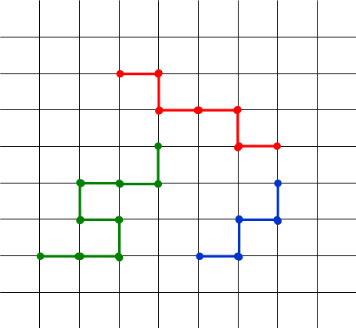

Figure 20. Random walks on a grid

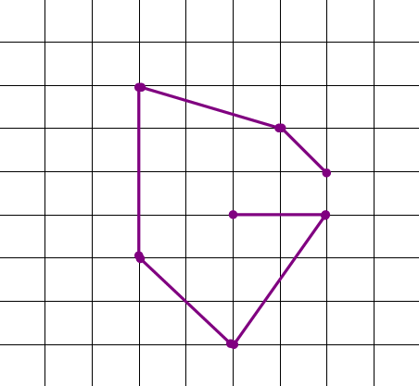

Figure 21. A simple line-string on a grid

In order to generate these more general types of line-strings, the algorithm first generates a random number numSeg between 1 and MaxSeq, which is the actual number of line segments that will make up the line-string. The algorithm then iteratively randomly generates the numSeg + 1 points that make up the line-string, in order, from beginning to end. The points are generated in such a way that 1) each individual segment has length at most MaxSegSpan, 2) the line-string never leaves the grid, and 3) so that the resulting line-string is “simple” i.e., the line-string never crosses back over itself. These properties are checked by the ValidPoint method which is called on line 16. The method makes use of straight-forward geometric calculations, and so is left out for the sake of brevity. It should be noted, however, that a single call to ValidPoint for each newly generated line segment, requires comparison to all previously generated line segments in the line-string. Consequently, each call to ValidPoint will require O(MaxSeg) time.

Note that when MaxSegSpan = 1, the resulting line-string could be a traditional walk on the grid. However, when MaxSegSpan > 1, the resulting line-string might consist of segments that are longer than one grid-cell, and consequently have slope other than 0 or 1. For example, Figure 22 shows a segment where the vertical segment span is 3 and the horizontal span is 2.

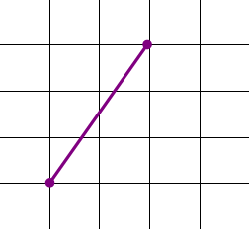

Figure 22. A segment of line-string on a grid

Also note that the loop beginning on line 12 iteratively attempts to randomly generate a point defining the next segment of the line-string. Conceivably this could have been replaced by an exhaustive search algorithm that checked every possible point within a distance of MaxSegSpan of the current point, but this would have resulted in a worst-case running time of O(MaxSegSpan² * MaxSeg). Although we did not implement this version of the algorithm, we have found the randomized version of the algorithm executes very quickly in practice. More technically, assuming that each valid next point can be generated within a small number of attempts, c, the expected running time would be O(c * MaxSeg). As conveyed on line 11 of the algorithm, the loop beginning on line 12 is executed numSeg times to generate a line-string, which would require O(c * MaxSeg²) time because numSeg depends on MaxSeg.

4.4.1.2.2 The Point-Sweeping Algorithm
The point-sweeping algorithm is conceptually much simpler than the algorithm presented in the previous section. It is, however, less efficient since it has a quadratic worst-case running time. Furthermore, unlike the previous algorithm, we know of no straight-forward way to reduce this running time by using randomization, or some other technique.

In addition to MaxSeg, the algorithm requires the user to enter the dimensions (h for height, and w for width) of the bounding-box within which each line-string is generated. If h = w then each line-string is generated in a square bounding box. On the other hand, if h is relatively small and w is relatively large, e.g., h = 5 and w = 100, then each line-string is generated in a wide, short box, thereby resulting in line-strings that are somewhat horizontal in appearance. Similarly if w is relatively large and h is relatively small, then the resulting line-strings would be relatively vertical in appearance. Generating each line-string in a bounding box in this manner allows the user control over the size, span and shape of the resulting line-strings.

Given h, w, and MaxSeg, the algorithm first generates some number, between 2 and MaxSeg + 1, of unique points in a box with dimensions h and w. These points are then connected into a line-String by sweeping across the bounding-box from left-to-right, and top-to-bottom order. As shown in Figure 23, this results in a line-string that has a somewhat horizontal zig-zag pattern within the bounding-box (represented by a blue dashed rectangle).

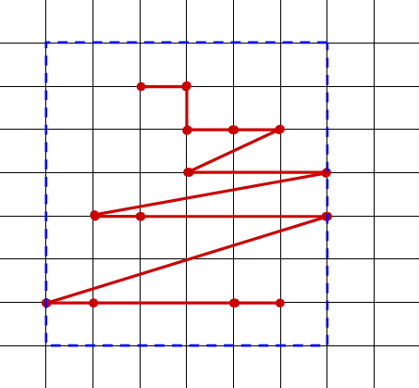

Figure 23. A line-string created by the point-sweeping algorithm

Once the line-string is generated in the bound-box, the bounding-box is then randomly placed on the grid, by generating a random x-offset and a random y-offset, as shown in Figure 24. After repeating this process a total of N times, then end result is a collection of N line-strings, randomly distributed on the grid, each bounded by the constraints of the dimensions of the bounding box.

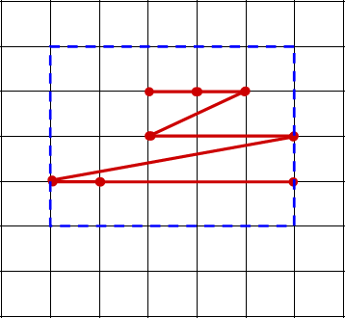

Figure 24. Placing a line-string via a bounding box

Generating the unique points that make up a line-string presents the same problem described in Section 4.4.1.1. Consequently, generating a collection of n unique points in a grid of size h by w takes worst-case time O(hw + n). This includes both the time to initialize the 2-dimension grid array, which is O(hw), and the time to generate the n points O(n). Since n must be less than hw, this reduces to O(hw). The points can then be connected by sweeping across the bounding-box, or rather the 2-dimensional grid array as described above. This also takes O(hw) time. Combining the two steps then gives a total of O(hw) time for each line-string.

4.4.1.3. Simple No-hole Polygons
In this section we describe an algorithm for generating a collection of random, simple, no-hole polygons. Before presenting the algorithm, it should be noted that the problem of generating random polygons has been considered by numerous authors, and a good summary of previous work is given by Dailey and Whitfield [Dailey 2008]. In general, the basic problem considered by most authors is the same – how to efficiently generate a random polygon on a collection of n given points. The main difficulty of the problem being that the resulting polygon should be a truly random one, selected from among all possible polygons on those n points.

Each polygon generated by our algorithm will have up to MaxVer vertices, which is one parameter input by the user. To be randomly placed on the grid, each polygon is created within a random bounding-box, where the size of the bounding-box is specified by the user. At the beginning of generation, this bounding-box is placed on a random spot on the grid, thereby placing the resulting polygon on a random spot on the grid. The algorithm, which is called GenPolygon, is shown in Figure 25.

GenPolygon: Generates a collection of N random, simple, no-hole polygons.
Input: N – the number of polygons to be generated.
MaxVer – the maximum number of vertices per polygon, where MaxVer ≥ 3
SideLeng – the length of the side of a bounding box, where SideLeng ≥ 1
Output: A list of N simple, no-hole polygons, each possessing up to MaxVer vertices.
(1) CNT = 0;
(2) while CNT < N do // generate N random no-hole polygons
(3) // the number of vertices of the polygon
(4) numVer = randomInt(3, MaxVer);
(5)
(6) // generate the lower left corner (x, y) of a random bounding square
(7) x = randomInt(0, mapMaxCoor − SideLeng);
(8) y = randomInt(0, mapMaxCoor − SideLeng);
(9)
(10) // generate the numVer vertices within the bounding square
(11) for 1 to numVer do
(12) while TRUE do
(13) Xshift = randomInt(0, SideLeng);
(14) Yshift = randomInt(0, SideLeng);
(15)
(16) if ValidVertex(x + Xshift, y + Yshift) then
(17) output (x + Xshift, y + Yshift);
(18) break;
(19) end if
(20) end while
(21) end for
(22)
(23) CNT = CNT + 1;
(24) end while

Figure 25. An algorithm for generating a collection of N random Polygons.

The reader will note that the algorithm for generating polygons is similar to the one for generating line-strings, in that a polygon is generated as a sequence of points, one after the other. Similarly, as each point is generated, it must be tested to determine that the point is “valid”, and ensures that the sequence indeed form a polygon. More specifically, because a simple, no-hole polygon is a linear-ring, a valid vertex (x_{n}, y_{n}) will not duplicate any previously generated vertex, or lie on any existing edge of the polygon. Furthermore, neither of the segments (x_{n - 1}, y_{n - 1}) → (x_{n}, y_{n}) and (x_{n}, y_{n}) → (x₀, y₀) will intersect the finished part of the polygon. The validness of vertex (x_{n}, y_{n}) in a simple, no-hole polygon is given collectively by the following conditions:

- (x_{n}, y_{n}) falls in the bounding square;
- (x_{n}, y_{n}) does not duplicate any previously generated vertex of the polygon;
- (x_{n}, y_{n}) does not lie on any existing edge of the polygon;
- (x_{n - 2}, y_{n - 2}), (x_{n - 1}, y_{n - 1}) and (x_{n}, y_{n}) are not collinear (i.e. the two consecutive edges do not lie on the same straight line)
- (x_{n - 1}, y_{n - 1}) → (x_{n}, y_{n}) does not cross any previously generated vertex of the polygon;
- (x_{n - 1}, y_{n - 1}) → (x_{n}, y_{n}) does not intersect any existing edge of the polygon;
- (x_{n - 1}, y_{n - 1}), (x_{n}, y_{n}) and (x₀, y₀) are not collinear;
- (x_{n}, y_{n}) → (x₀, y₀) does not cross any previously generated vertex of the polygon;
- (x_{n}, y_{n}) → (x₀, y₀) does not intersect any existing edge of the polygon.

As with the generalized random walk line-string algorithm, this algorithm also makes use of randomization, and must perform a somewhat expensive O(MaxVer) validity test for each segment generated. Assuming each valid next point can be generated within a small number of attempts, c, generating a polygon would require O(c * MaxVer²) time.

4.4.1.4. Squares
In this section we present an algorithm for generating a collection of random squares. As with line-strings and more general polygons, the size and placement of the random squares are controlled by several parameters specified by the user. For example, each square is generated within a bound-box whose size is specified by the user. In addition, each square is randomly “tilted”, such that the sides of the square are not necessarily parallel to the x and y axes.

One question that should be addressed is why a separate algorithm for generating squares is provided, since a square is in fact a polygon and can consequently be generated by the algorithm from the previous section. The answer is that squares can be generated much more efficiently given their simple structure. More specifically, each square can be generated in constant time. Similarly, we present an algorithm for generating triangles in the next section for the same reason. Conceivably, algorithms for other special cases of polygons could be constructed as well.

The algorithm for generating random squares, which is called GenSquare, is shown in Figure 26.

GenSquare: Generates a collection of N random squares.
Input: N – the number of squares
SideLeng – the length of the side of the bounding box for each square
Output: A list of N squares
(1) CNT = 0;
(2) while CNT < N do // generate N random squares
(3) // the random lower-left corner (x, y) of the bounding square
(4) x = randomInt(0, mapMaxCoor − SideLeng);
(5) y = randomInt(0, mapMaxCoor − SideLeng);
(6)
(7) // the x-range [x₁, x₂] of the square
(8) x₁ = randomInt(x, x + SideLeng − 1);
(9) x₂ = randomInt(x₁ + 1, x + SideLeng);
(10) d = x₂ − x₁;
(11)
(12) // the y-range [y₁, y₂] of the square
(13) y₁ = randomInt(y, y + SideLeng − d);
(14) y₂ = y₁ + d;
(15)
(16) // deviation s determines how much the square will be randomly tilted
(17) s = randomInt(0, d);
(18)
(19) // the four vertices of the square
(20) output (x₁ + s, y₁), (x₂, y₁ + s), (x₂ − s, y₂) and (x₁, y₂ − s);
(21)
(22) CNT = CNT + 1;
(23) end while

Figure 26. An algorithm for generating a collection of N random Squares.

The reader can easily verify that each step in the body of the main loop can be executed in constant time. Consequently each square can be generated in constant time.

4.4.1.5. Triangles
In this section we present an algorithm for generating a collection of N random triangles. As discussed in this section, technically triangles can be generated using the more general algorithm for generating polygons. We included this algorithm, however, because triangles can be generated much more efficiently using a special-purpose algorithm.

Much like line-strings, polygons and squares, the vertices of each triangle are all randomly generated within a bounding-box, the dimensions of which are specified by the user. For each generated triangle, this bounding-box is placed randomly on the grid, thereby placing the triangle in a random location on the grid.

The algorithm, which is called GenTriangle, is shown in Figure 27.

GenTriangle: Generates a collection of N random triangles.
Input: N – the number of triangles.
Height – the height of a bounding box.
Width – the width of a bounding box.
Output: A list of N triangles.
(1) CNT = 0;
(2) while CNT < N do // generate N random triangles
(3) // generate the lower left corner (x, y) of the bounding rectangle
(4) x = randomInt(0, mapMaxCoor − Width);
(5) y = randomInt(0, mapMaxCoor − Height);
(6)
(7) // generate the first vertex (x₁, y₁) of the triangle
(8) x₁ = x + randomInt(0, Width);
(9) y₁ = y + randomInt(0, Height);
(10) store (x₁, y₁);
(11)
(12) // generate the second vertex (x₂, y₂) of the triangle
(13) x₂ = x + randomInt(0, Width);
(14) y₂ = y + randomInt(0, Height);
(15) while (x₁, y₁) = (x₂, y₂) do
(16) x₂ = x + randomInt(0, Width);
(17) y₂ = y + randomInt(0, Height);
(18) end while
(19) store (x₂, y₂);
(20)
(21) // generate the third vertex (x₃, y₃) of the triangle
(22) x₃ = x + randomInt(0, Width);
(23) y₃ = y + randomInt(0, Height);
(24) while ( (x₁, y₁) = (x₃, y₃) OR
(x₂, y₂) = (x₃, y₃) OR
(x₁, y₁) & (x₂, y₂) & (x₃, y₃) are collinear ) do
(25) x₃ = x + randomInt(0, Width);
(26) y₃ = y + randomInt(0, Height);
(27) end while
(28) store (x₃, y₃);
(29)
(30) output (x₁, y₁), (x₂, y₂) and (x₃, y₃);
(31)
(32) CNT = CNT + 1;
(33) end while

Figure 27. An algorithm for generating a collection of N random Triangles

The algorithm generates three random points within the bounding-box for each triangle. In order to form a triangle, the algorithm must guarantee that all three are unique, and so a test is performed in side of the main loop of the algorithm to ensure this. Technically the loops are randomized, in the sense that they repeatedly generate the second and third random points until unique points are generated, and consequently these loops could execute for an arbitrary amount of time. In practice however, we expect that in most cases three unique points will be found very quickly in a small number of attempts. Assuming that is the case then the algorithm will generate each triangle in linear time.

4.4.2 Import Data to Database
Our data generator saves its WKT data in five text files named Point.txt, LineString.txt, Polygon.txt, Square.txt and Triangle.txt for the five geometry objects. The data can be easily imported to SQL Server from text files in two simple steps. First, the data is directly imported to temporary tables, each with a single column of string type. For example, Figure 28 shows two commands for each type of the data. One is for creating the table, and the other for performing the bulk insert from a text file containing the data specified in WKT format.

CREATE TABLE PT
( Position_Description nvarchar(max) )
BULK INSERT PT
FROM '[Directory]\Point.txt'

CREATE TABLE LS
( Trajectory_Description nvarchar(max) )
BULK INSERT LS
FROM '[Directory]\LineString.txt'

CREATE TABLE PG
( Shape_Description nvarchar(max) )
BULK INSERT PG
FROM '[Directory]\Polygon.txt'

CREATE TABLE SQ
( Shape_Description nvarchar(max) )
BULK INSERT SQ
FROM '[Directory]\Square.txt'

CREATE TABLE TG
( Shape_Description nvarchar(max) )
BULK INSERT TG
FROM '[Directory]\Triangle.txt'

Figure 28. SQL code for importing WKT data

Second, the data is copied from these temporary tables to the WKT columns of the tables of the Space Bench schema (see Figure 16) as shown in Figure 29.

INSERT INTO Point (Position_Description)
SELECT Position_Description
FROM PT

INSERT INTO LineString (Trajectory_Description)
SELECT Trajectory_Description
FROM LS

INSERT INTO Polygon (Shape_Description)
SELECT Shape_Description
FROM PG

INSERT INTO Square (Shape_Description)
SELECT Shape_Description
FROM SQ

INSERT INTO Triangle (Shape_Description)
SELECT Shape_Description
FROM TG

Figure 29. SQL code for moving WKT Data to schema tables

The WKT data is then automatically converted to the internal geometry data type by means of the ST methods shown in Figure 16. Once loaded into the Space Bench schema, it is then stored in the internal proprietary format, and available for optimizing, indexing, and querying by the DBMS.

4.5 The Space Bench Queries

In this section we present the queries used by Space Bench to evaluate DBMS performance. Each SQL query of Space Bench is intended to be non-trival, sophisticated query that includes OGC spatial operations. Based on the work of Shakhar [Shakhar 2003], we divide the queries into the following categories: point, range, nearest-neighbor, intersection, containment, and spatial join.

Note that some queries have unspecified parameters, which are indicated by a pair of brackets in the query. As noted previously, we modeled Space Bench after the TPC-H benchmark, and this is consistent with queries in that. The intention is that a test program submitting the queries in accordance with the TPC specifications would randomly generate these values before submitting the query to the DBMS.

Point Queries:

(Q1) Find all triangles which are connected to (i.e. “touch”) a point and have area of at least 3000 square units.

SELECT id, Shape, Shape_Description
INTO T
FROM Triangle
WHERE Triangle.Shape.STArea() >= 3000

SELECT DISTINCT T.id AS TriangleID,
T.Shape_Description AS Shape,
Point.Position_Description AS TouchingPoint
FROM Point, T
WHERE T.Shape.STTouches(Point.Position) = 1

(Q2) Find all squares which touch a point, and are more than 3500 units away from the Origin.

DECLARE @Origin geometry
SET @Origin = geometry::STPointFromText('POINT (0 0)', 0)

SELECT id, Shape, Shape_Description
INTO S
FROM Square
WHERE 3500 < Square.Shape.STDistance(@Origin)

SELECT S.id AS SquareID,
S.Shape_Description AS Shape,
Point.Position_Description AS TouchingPoint
FROM Point, S
WHERE S.Shape.STTouches(Point.Position) = 1

Range Queries:

(Q3) Find all points contained in a given polygon.

SELECT DISTINCT Point.id, Point.Position_Description AS Position
FROM Point, Polygon
WHERE Polygon.id = [POLYGON-ID] AND
Polygon.Shape.STContains(Point.Position) = 1

(Q4) Find all points that are within 500 unit away from point (1000, 1000), and that are contained in a polygon with at least 7 edges.

SELECT DISTINCT Point.id, Point.Position_Description AS Position
FROM Point, Polygon
WHERE (Polygon.Shape.STNumPoints() >= 7 AND
Polygon.Shape.STContains(Point.Position) = 1)
AND
Point.Position.STDistance('POINT (1000 1000)') <= 500

Note that there may be three-vertex polygons (triangles) in the Polygon table. This query will test the containing relation of all polygons / triangles with every single point.

(Q5) Find all the points within 30 units to a given lines-tring.

SELECT Point.id, Point.Position_Description
FROM Point, LineString
WHERE LineString.id = [LINESTRING-ID] AND
LineString.Trajectory.STBuffer(30).STContains(Point.
Position) = 1

(Q6) Find all polygons, squares and triangles within 30 units to a given line-string.

SELECT Polygon.id AS Polygon_ID,
Polygon.Shape_Description AS Polygon_Shape
FROM Polygon, LineString
WHERE LineString.id = [LINESTRING-ID] AND
LineString.Trajectory.STBuffer(30).STOverlaps(Polygon.
Shape) = 1

SELECT Square.id AS Square_ID,
Square.Shape_Description AS Square_Shape
FROM Square, LineString
WHERE LineString.id = [LINESTRING-ID] AND
LineString.Trajectory.STBuffer(30).STOverlaps(Square.
Shape) = 1

SELECT Triangle.id AS Triangle_ID,
Triangle.Shape_Description AS Triangle_Shape
FROM Triangle, LineString
WHERE LineString.id = [LINESTRING-ID] AND
LineString.Trajectory.STBuffer(30).STOverlaps(Triangle.
Shape) = 1

Nearest Neighbor Queries:

(Q7) Find the closest point to a given point (x, y).

CREATE VIEW PointDistance AS
SELECT Point.id,
Point.Position_Description,
Point.Position.STDistance(geometry::STPointFromText(
'[POINT (x y)]', 0)) AS Distance
FROM Point

SELECT *
FROM PointDistance
WHERE Distance = (SELECT Min(Distance) FROM PointDistance)

(Q8) Find the closest polygon to a given point (x, y).

CREATE VIEW PolygonDistance AS
SELECT Polygon.id,
Polygon.Shape_Description,
Polygon.Shape.STDistance(geometry::STPointFromText(
'[POINT (x y)]', 0)) AS Distance
FROM Polygon

SELECT *
FROM PolygonDistance
WHERE Distance = (SELECT Min(Distance) FROM PolygonDistance)

(Q9) Find the closest line-string intersection to a given point (x, y).

CREATE VIEW Line_Intersection AS
SELECT LineString1.id AS LineA,
LineString2.id AS LineB,
LineString1.Trajectory.STIntersection(LineString2.
Trajectory) AS Intersection
FROM LineString AS LineString1, LineString AS LineString2
WHERE LineString1.id <> LineString2.id AND
LineString1.Trajectory.STIntersects(LineString2.
Trajectory) = 1

CREATE VIEW Intersect_Distance AS
SELECT LineA,
LineB,
Intersection,
Intersection.STDistance(geometry::STPointFromText(
'[POINT(x y)]', 0)) AS Distance
FROM Line_Intersection

SELECT *
FROM Intersect_Distance
WHERE Distance = (SELECT Min(Distance) FROM Intersect_Distance)

Intersection Queries:

(Q10) Find all polygons, squares and triangles overlapping a given rectangle, whose vertices are (x1,y1), (x2,y2), (x3,y3) & (x4,y4).

DECLARE @h geometry
SET @h = geometry::STPolyFromText('[POLYGON ((x1 y1,
x2 y2, x3 y3, x4 y4, x1 y1))]', 0)

SELECT Polygon.ID AS PolygonID
FROM Polygon
WHERE Polygon.Shape.STOverlaps(@h) = 1

SELECT Square.ID AS SquareID
FROM Square
WHERE Square.Shape.STOverlaps(@h) = 1

SELECT Triangle.ID AS TriangleID
FROM Triangle
WHERE Triangle.Shape.STOverlaps(@h) = 1

(Q11) For all polygons, squares and triangles, find the crossing line-strings.

SELECT Polygon.id AS PolygonID, LineString.id As LineStringID
FROM Polygon, LineString
WHERE LineString.Trajectory.STCrosses(Polygon.Shape) = 1

SELECT Square.id AS squareID, LineString.id As LineStringID
FROM Square, LineString
WHERE LineString.Trajectory.STCrosses(Square.Shape) = 1

SELECT Triangle.id AS TriangleID, LineString.id As LineStringID
FROM Triangle, LineString
WHERE LineString.Trajectory.STCrosses(Triangle.Shape) = 1

Containment Queries:

(Q12) Find all polygons and line-strings that are contained in a given rectangle, whose vertices are (x1,y1), (x2,y2), (x3,y3) and (x4,y4).

DECLARE @h geometry
SET @h = geometry::STPolyFromText('[POLYGON ((x1 y1, x2 y2,
x3 y3, x4 y4, x1 y1))]', 0)

SELECT LineString.id AS LineStringID
FROM LineString
WHERE @h.STContains(LineString.Trajectory) = 1

SELECT Polygon.id AS PolygonID
FROM Polygon
WHERE @h.STContains(Polygon.Shape) = 1

Spatial Join Queries:

(Q13) Find all line-strings that cross a polygon, a square and a triangle.

SELECT LineString.id
FROM LineString, Polygon, Square, Triangle
WHERE LineString.Trajectory.STCrosses(Polygon.Shape) = 1 AND
LineString.Trajectory.STCrosses(Square.Shape) = 1 AND
LineString.Trajectory.STCrosses(Triangle.Shape) = 1

Chapter 5

Space Bench Proof-of-Concept

This chapter describes the results of a proof-of-concept test using Space Bench. The reader should note that this test was not intended to be a full and complete benchmark test, but rather a simple experiment designed to show that the Space Bench products do indeed work. A full benchmark test using Space Bench is considered beyond the scope of this thesis, and left as future work.

The minimum system required for this test includes a computer and DBMS which supports the spatial capabilities required by the benchmark, i.e., OGC types and operations. More specifically, the resources used include:
- Computer System: 1.73 GHz Pentium® dual-core CPU, 1 GB RAM,
32-bit Windows® 7 Ultimate
- Integrated Environment: SQL Server Management Studio
- Rational DBMS: SQL Server 2008 R2
- Space Bench: the schema, the data generator, and the SQL query set
The benchmark results are query timings, while the intermediate product of the test includes text files of WKT data.

Creating the Spatial Database
To create the spatial database, the user must first log into SQL server via the management studio. The studio Object Explorer is then used to create the spatial database, as shown in Figure 30.

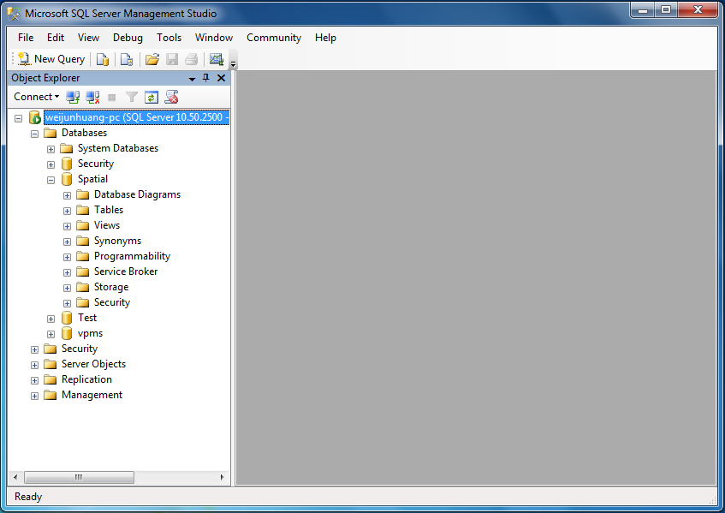

Figure 30. Creating a spatial database using SQL Server.

Creating the Schema Tables - Point, LineString, Polygon, Square & Triangle
In order to create the schema tables, the DDL in Figure 16 (Section 4.3) is executed using the script editor of the management studio. The code and the tables are shown in figure 31.

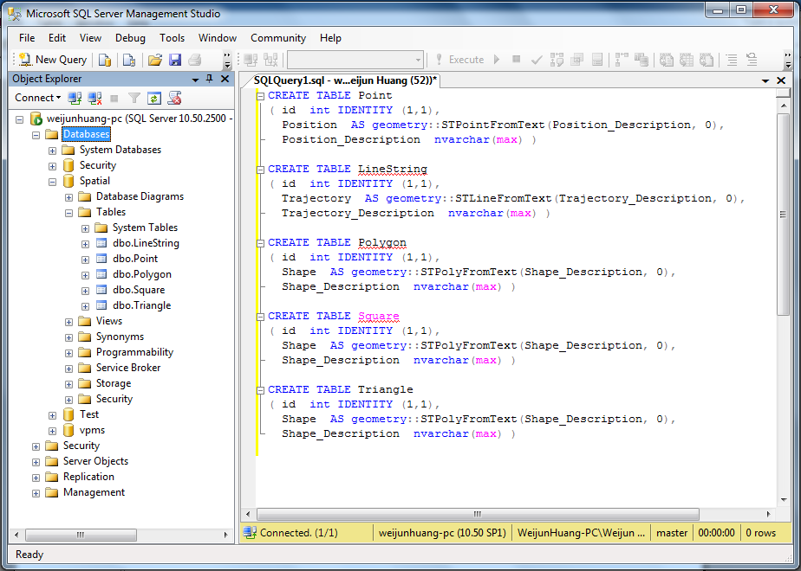

Figure 31. Creating the Space Bench tables.

Generating Spatial Data in WKT Format
As noted previously, when the data generator is executed, the user is prompted for a variety of parameters that determine various properties of the generated data. For example, the parameter values used in this experiment are shown in Figure 32.

0. Grid Size: 3000 * 3000
1. Points
Number: 50 * 10^3
2. LineStrings
Number: 100
Max Number of Segments per Linestring: 20
Max Span of a Segment in x & y: 100
3. Polygons
Number: 100
Max Number of Vertices per Polygon: 10
Side Length of Bounding Box: 150
4. Squares
Number: 100
Max Side Length: 100
5. Triangles
Number: 100
Height of Bounding Box: 100
Width of Bounding Box: 150

Figure 32. Sample values of parameters for geometry objects.

The main outcome of this step is a collection of files containing the generated data in WKT format. For example, for the parameters in Figure 32, five files were produced, one for each type of geometric object, and Figure 33 shows the contents of the Point.txt file.

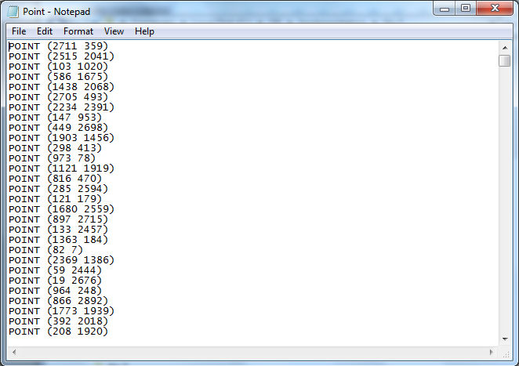

Figure 33. Example of point data in WKT format.

Although not required to use the benchmark, the generator is also capable of displaying the geometry objects that it generates. For example, Figure 34 shows the collection of points (green), line-strings (black), and polygons (including squares and triangles) generated based on the parameters from Figure 32.

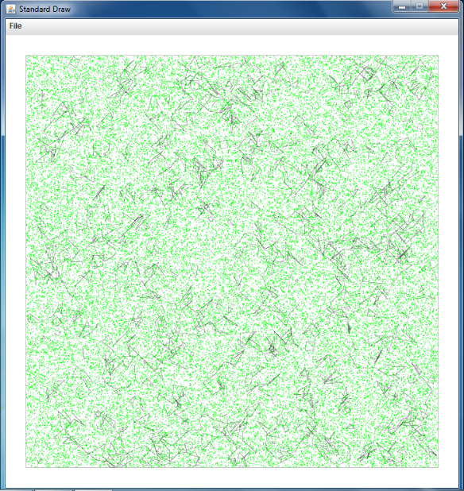

Figure 34. Visual display of data generated by Space Bench.

Alternatively, the data can also be visualized by the SQL Server management studio once the data has been stored in the spatial database.

Importing the WKT Data to Temporary Tables
In order to load the data into the spatial database, it must first be imported to the temporary tables PT, LS, PG, SQ and TG described in Section 4.4.2. In particular, the code shown in Figure 28 (Section 4.4.2) is executed to create and load the five temporary tables, as shown in Figure 35.

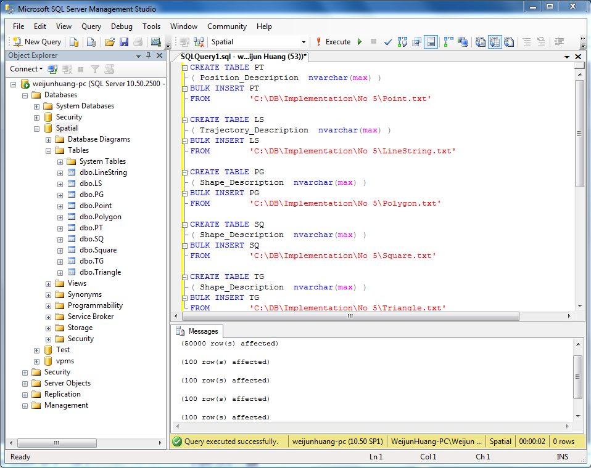

Figure 35. Creating the temporary tables and importing the data in WKT format.

Moving the Data to the Schema Tables
The next step is to copy the data from the temporary tables to the schema tables. This is done by executing the code in Figure 29 (Section 4.4.2). The WKT data is then automatically converted to geometrically typed data in the second column of each of the schema tables.

At the completion of this step, the numbers of rows in the schema tables were the same as the parameters provided during data generation. For example, Figure 36 shows the LineString table with the data from the LineString.txt file, which was generated by the data generator based on the parameters from Figure 32. In addition, Figure 37 shows the visualization of the line-strings by the management studio, with a small highlighted portion amplified in Figure 38.

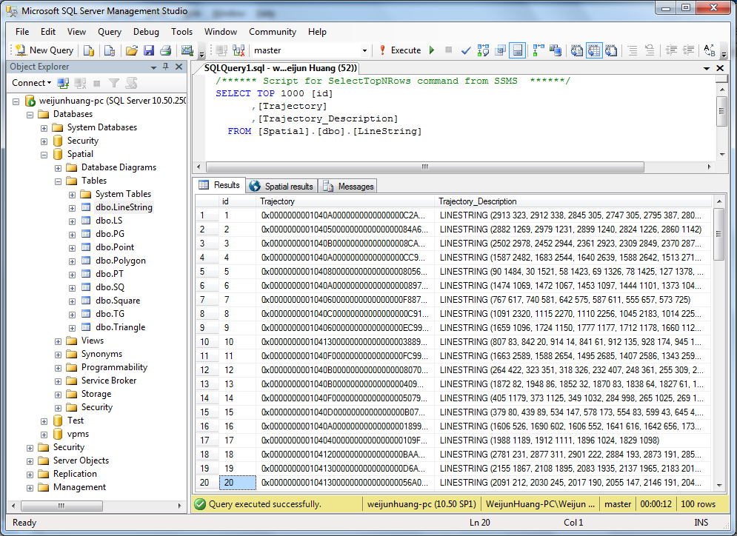

Figure 36. Example of LineString data in the spatial database.

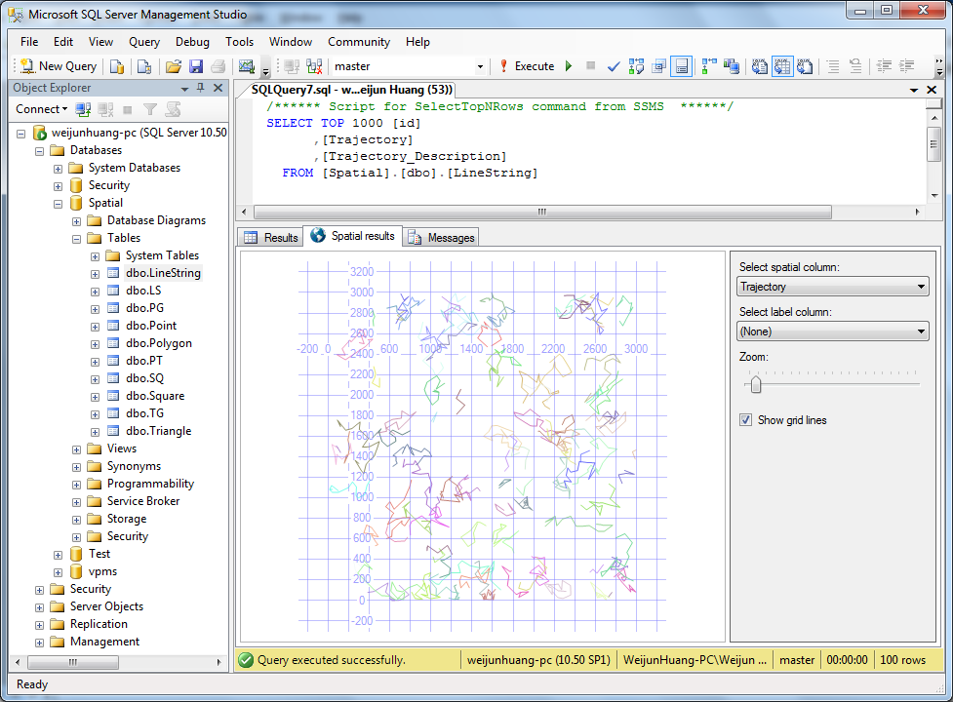

Figure 37. Visualization of geometry objects by SQL Server.

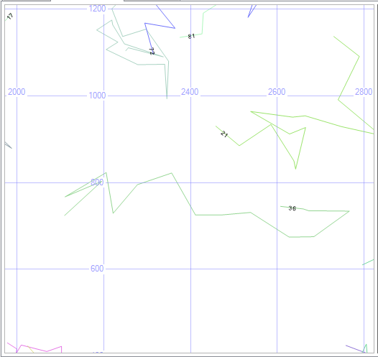

Figure 38. Amplification of a small region of data from Figure 37.

Executing the Space Bench Queries
As a final step, we executed all of the queries from Section 4.5. Additionally, we also recorded the execution time for each query. However, as noted at the beginning of this chapter, these measurements are informal and do not constitute a carefully controlled, precise benchmark application.

As described in Section 4.5, many of the queries had parameters that were provided prior to execution. For this test the following values were used:
Q3: polygon no = 10
Q5: linestring no = 20
Q6: linestring no = 25
Q7: POINT (3 4)
Q8: POINT (100 100)
Q9: POINT (500 500)
Q10, 12: POLYGON ((500 1000, 2500 1000, 2500 2000, 500 2000, 500 1000))

Table 3 shows the execution times reported by the SQL Server management studio. Note that times are reported to a precision of 1 second by SQL Server, and consequently 0 was reported for some queries because they took so little time to execute.

query | Q1 | Q2 | Q3 | Q4 | Q5 | Q6 | Q7
query time | 47 | 34 | 5 | 36 | 12 | 1 | 10

query | Q8 | Q9 | Q10 | Q11 | Q12 | Q13
query time | 0 | 7 | 0 | 7 | 0 | 3

Table 3. Query times for Space Bench queries using SQL Server.

For a more complete and accurate benchmark test, procedures such as those outlined by the TPC-H benchmark specification would need to be used [TPC 2011]. Our purpose here was simply to verify that the components of Space Bench worked, as they would be required to for a formal benchmark.

Chapter 6

Conclusions and Future Work

In this thesis we presented Space Bench, a benchmark for measuring the performance of spatial database systems that support the OGC spatial standard for relational databases. The various components of the benchmark were presented, including the spatial database schema, the spatial database generator, and the spatial queries. As part of the data generator, we also presented new algorithms for generating random line-strings and polygons. We also presented a list of 13 non-trivial spatial queries, which form the basis or the benchmark performance test. Finally, we also performed a brief, proof-of-concept experiment to verify that all components of the benchmark worked as planned.

Several additional areas of future work remain. First, additional algorithms for generating spatial data efficiently are certainly worthy of pursuit. In particular, few of the published algorithms for generating polygons claim or prove that the generated polygons are truly “random.” Similarly, we make no such claim for the algorithms presented here. Second, although we have performed a proof-of-concept test for Space Bench, a more thorough and carefully controlled benchmark test would be appropriate. Among other things, this would involve the development of a program that would use the Space Bench queries to generate a synthetic system load, in a manner similar to the TPC benchmarks [TPC 2011].

References

Anon, et. al., "A Measure of Transaction Processing Power," in "Readings in Database Systems", edited by Michael Stonebraker, Morgan Kaufman, 1985

Boral, H., DeWitt, D.J., Friedland, D., Jarrell, N., and Wilkinson, W. K., "Implementation of the Database Machine DIRECT," IEEE Transactions on Software Engineering, November, 1982

Dailey, D., and Whitfield, D., “Constructing Random Polygons,” SIGITE ’08, October 16-18, Cincinnati, Ohio.

DeWitt, D.J., "DIRECT - A Multiprocessor Organization for Supporting Relational Database Management Systems," IEEE Transactions on Computers, June, 1979

DeWitt, D.J., The Wisconsin Benchmark: Past, Present, and Future, 2nd draft, University of Wisconsin, http://www.eecs.umich.edu/~jag/eecs584/papers/dewitt_bench.pdf

Elmasri, R. & Navathe, S.B., 2010, Fundamentals of Database Systems, Sixth Edition, Addison Wesley.

Herring, J.R. (Editor), 2010, OpenGIS® Implementation Standard for Geographic Information – Simple feature access – Part 1: Common architecture & Part 2: SQL option, version 1.2.1, Open Geospatial Consortium Inc.

Microsoft® MSDN Library

Paul, S., 2008, Database Systems Performance Evaluation Techniques, Washington University in St. Louis, http://www.cse.wustl.edu/~jain/cse567-08/ftp/db/index.html

Ray, S., Simion, B., & Brown, A.D., 2011, Jackpine: A Benchmark to Evaluate Spatial Database Performance, ICDE Conference, IEEE

Shekhar, S. & Chawla, S., 2003, Spatial Databases: A Tour, First Edition, Pearson Education Inc.

Silberschatz, A., Korth, H.F., & Sudarshan, S., 2010, Database System Concepts, Sixth Edition, McGraw-Hill

TPC (Transaction Processing Performance Council), http://www.tpc.org

TPC Benchmark C Standard Specification, 2010, version 5.11, Transaction Processing Performance Council

TPC Benchmark E Standard Specification, 2010, version 1.12.0, Transaction Processing Performance Council

TPC Benchmark H (Decision Support) Standard Specification, 2011, version 2.14.3, Transaction Processing Performance Council, San Francisco

